Upper and lower Leg Corrective Exercises

Self Myo Fascial Release with Foam Roller or Ball
Do these exercises whenever you can, ideally once per day for 15 minutes. Also perform Pre Exercise as a warm up or post exercise as cool down and before static stretching.
Hold on very tender areas for 30-90 seconds to help reduce lumps.
Focus on these areas for your condition.

Lateral Gastrocnemius/soleus Hamstrings
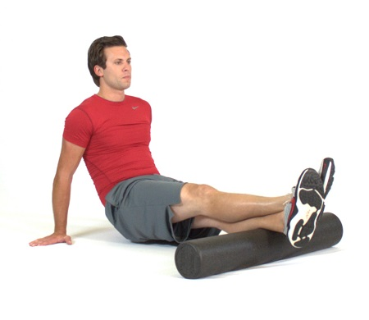

Hip Flexors TFL: fleshy muscle at the top of your IT band
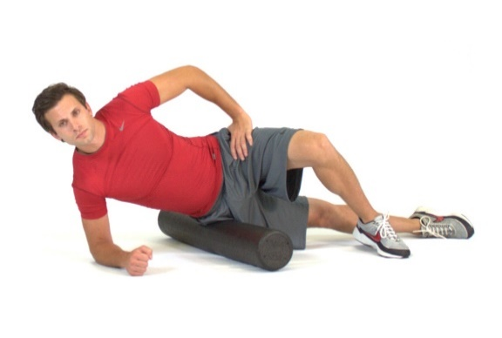
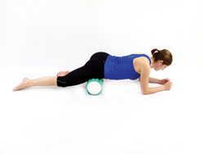

Adductors
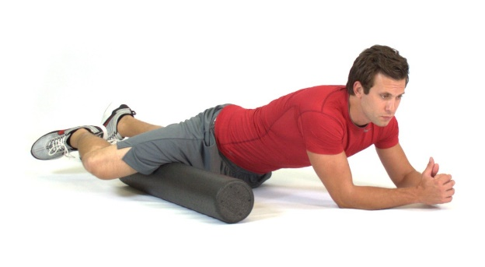

Static Stretches: 30 second hold/ 6-10 second isometric contraction, 30 sec hold
Gastrocnemius Soleus
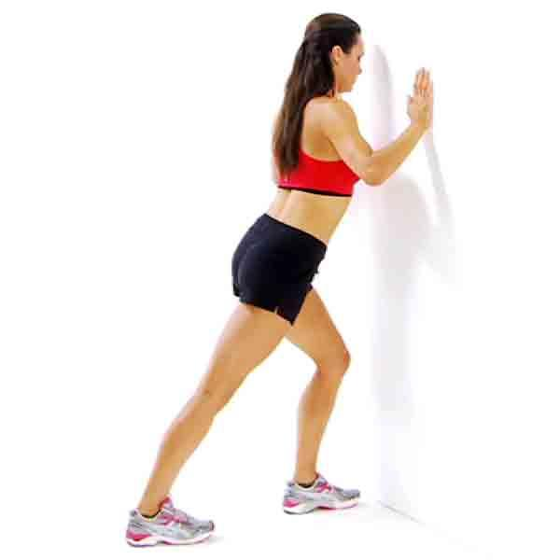
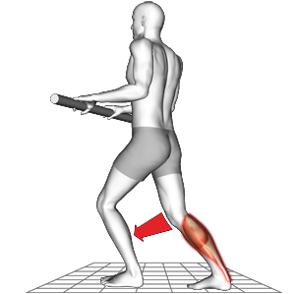
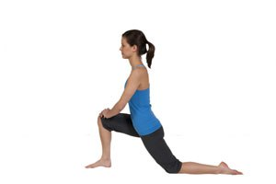Hip Flexors
Hamstrings Adductors
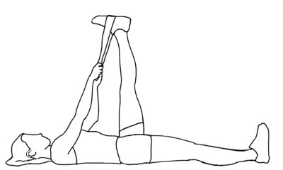
Isometric Activation and Strengthening
10 to 15 reps, 1 -2 sets
Tibialis Anterior Glut strengthening
(ensure abdominal muscles are pulled in as you lift each leg alternately)

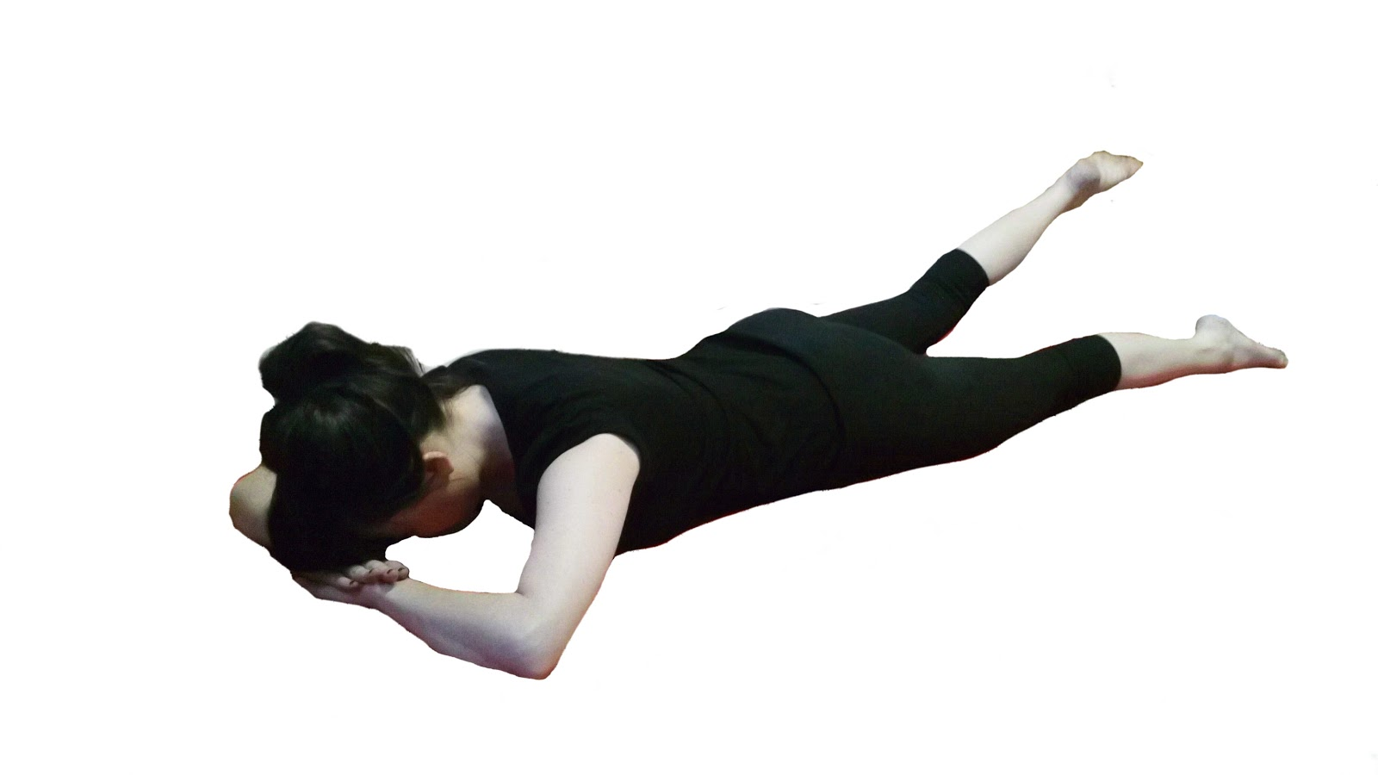

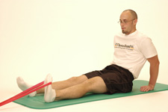

Erector Spinae Core stabilisers
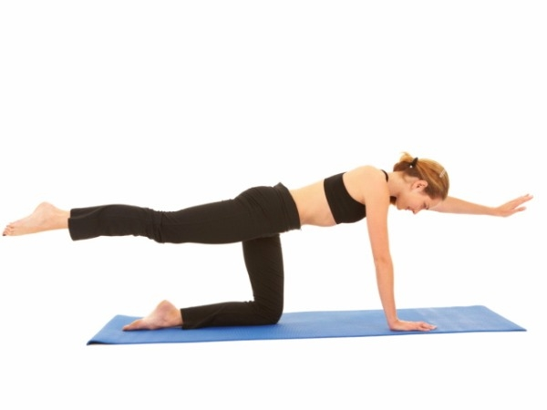

In addition to these exercises and stretches, I strongly recommend that you regularly attend either some form of flexibility class i.e. Pilates in addition to a resistance training class, preferably a kettlebell training class or circuit training. Please see my website www.iam-fitness.co.uk for further information regarding the classes I run.
You must aim to foam roll or stretch at least 3 times per week, of which stretching post exercise will class as a 1 of your stretching sessions per week.
References:
Hendrickson, T., 2009. Massage and Manual Therapy for Orthopedic Conditions. 2nd Ed. USA. Lippincott, Williams and Wilkins.
NASM Essentials of Corrective Exercise Training, 2014. 1st Ed. USA. Jones and Barlett Learning.

